Jose Francisco Ruiz -Tenor
vocediorfeo@gmail.com
310-753-9295
www.josefranciscoruiztenor.com
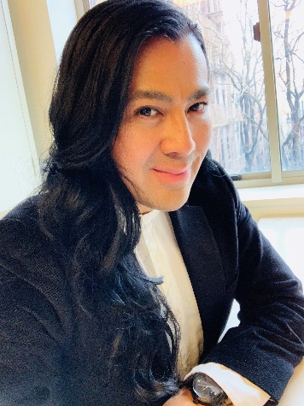

Upcoming Concerts
EmberArts, NYC Contemporary/ New Music Concert June 2023
Nubian Conservatory of Music Brooklyn, NY Caldara’s Stabat Mater Concert June 2023

ORATORIO
Haydn Die Schöpfung(Solo) Nubian Conservatory of Music Brooklyn 2022
Handel Messiah (Solo) Nubian Conservatory of Music Brooklyn 2021
Handel Israel in Egypt Resurrection Parish, Randolph, NJ 2019
Bach Cantanta no. 63 Nubian Conservatory of Music, Brooklyn 2017
Bach Cantanta no. 144 Nubian Conservatory of Music, Brooklyn 2017
Vivaldi Credo Nubian Conservatory of Music, Brooklyn 2016
Beethoven 9th Symphony Orchestra Amadeus of New York 2016
Soloist Spiritual St. Catherine AME Zion Church, New Rochelle 2016
Bach Cantata no. 21 Nubian Concervatory of Music, Brooklyn 2015
Bach Cantata no. 80 Nubian Concervatory of Music, Brooklyn 2013
Stainer Crufixicion First Baptist Church, Bronxville, New York 2012
Rossini Stabat Mater (solo) St. Barnabas Episopal Church, Brooklyn 2012
Handel Israel in Egypt Nubian Conservatory of Music, Brooklyn 2011
Mozart Requiem (understudy) Nubian Conservatory of Music, Brooklyn 2010
Handel Messiah Nubian Conservatory of Music, Brooklyn 2009
Bach Cantata 96, (solo) Cantata Singers of New York 2008
Bach Cantata 106 (solo) Cantata Singers of New York 2007
Bach B Minor Mass Cantata Singers of New York 2006
Crumb Ancient Voices of Children (solo) Manhattan School of Music 2004
Beethoven 9th Symphony Westwood Presbyterian Church 2004
Handel Messiah Westwood Presbyterian Church 1997- 2004
Haydn Die Shopfung Westwood Presbyterian Church 2004
Britten Mass Westwood Presbyterian Church 2003
Bernstein Chichester Psalms(solo) Westwood Presbyterian Church 2002
Orff Carmina Burana El Camino College Chorale 1999
Mozart Regina Caeli (solo) El Camino College Chorale 1997

CONDUCTORS MASTER CLASS VOICE TEACHERS DICTION
Deborah Simpkin King Carlo Pari Patricia McCaffrey Glenn Morton
Edward Gordon Mignon Dunn Rhonda Dillon Marianne Barrett
Kenneth Cooper Cynthia Hoffmann Christina Stanescu
David Labowitz Paul Sperry Kathryn LaBouff
John-Kevin Hilbert
Joanna Nachef
Winston Voegel
Sung Jin Hong

SCHOOL:
Manhattan School of Music, BA 2008

